**Name: Prudhvi Vardhan**

**Id: 22071880**

**Dataset link:** **https://www.kaggle.com/datasets/russellyates88/suicide-rates-overview-1985-to-2016**

**Github: https://github.com/pp23aai/AssignmentADS-1**

# Global Suicide Rates with Graphs

**Introduction:**

Suicide is a huge problem all over the world, and it affects people of all ages and genders. To figure out how to prevent it, we need to understand how suicide rates have changed over time and how they vary by age and gender. This report uses data visualization to analyze global suicide rates from 1985 to 2015. The three graphs give us a better handle on trends over time, differences by age group, and variations by gender.

**Graph 1: Worldwide suicide Totals Per 100K Pop by Region -Line chart**

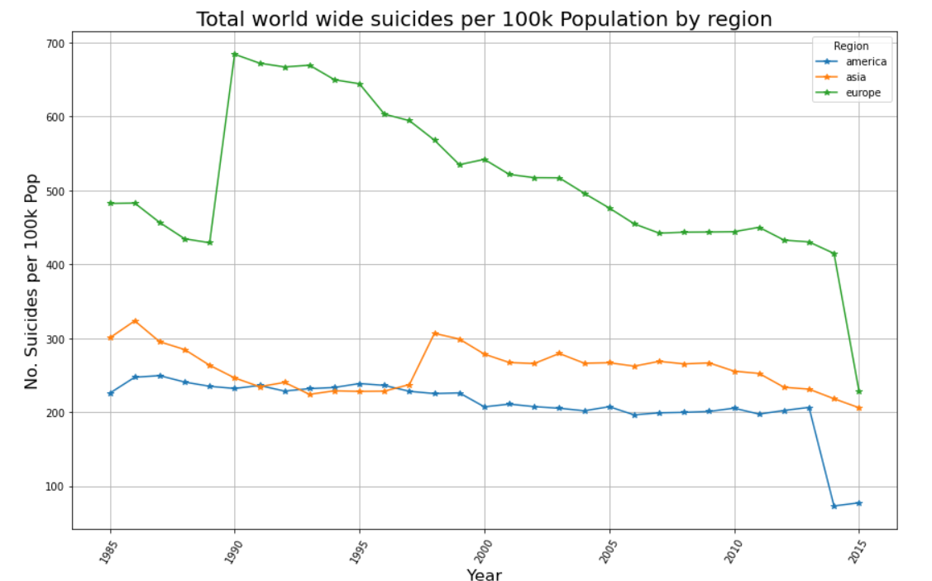

This graph is perfect for showing changes over time. The line chart shows global suicide rates per 100k people from 1985 to 2015 by region. It shows that the rates have decreased overall, but there were some spikes in the 1990s and 2000s.If we look at Europe specifically, we can see that it used to have higher suicide rates than Asia and the Americas, but the gap has narrowed recently.

**Graph 2: Total Global suicide’s by Age group in 1987 (Bar Chart)**

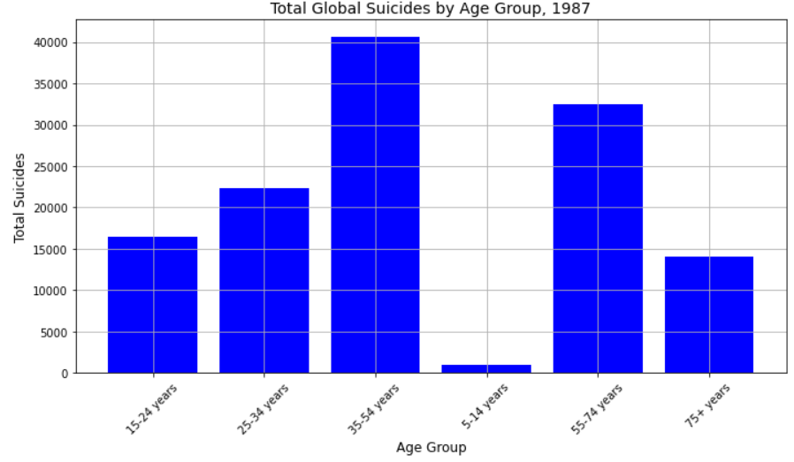

Bar charts are solid for comparing different things. I wanted to see how different age groups stacked up in one year and one place. Bar chart for Albania in 1987 showed us which age groups saw more suicides. This bar chart shows the total number of suicides by age group in 1987. The age group with the highest number of suicides is 25-54 years old, followed by the age group 55-74 years old. The age groups with the lowest number of suicides are 5-14 years old and 75+ years old.

**Graph 3: The Pie that's Divided (Pie Chart)**

This pie chart shows the percentage of global suicides by gender in 2015. The biggest slice of the pie is for males, at 76.8%. This means that for every 100 people who die by suicide, 77 are male. The smaller slice of the pie is for females, at 23.2%.

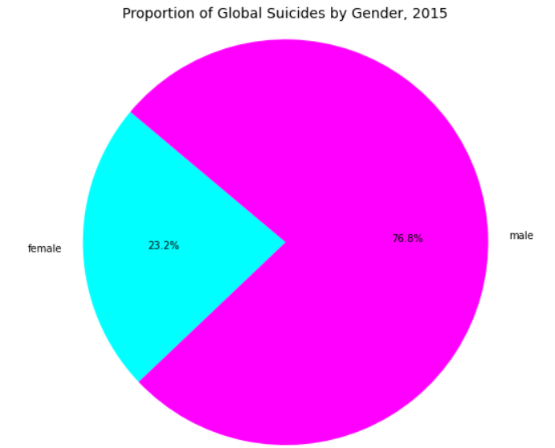

**Conclusion:**

To sum up, these graphs reveal some important trends and variations in global suicide data. The line chart shows that overall rates have decreased, but there have been some concerning spikes in certain regions. The bar chart highlights higher rates among certain age groups, such as 25-54 year olds. And the pie chart underscores the disproportionate impact on males. While rates have declined, suicide remains a pressing global concern. We need to keep monitoring patterns and develop targeted interventions to address this crisis. The story told through these three graphs underscores the need for more research and resources devoted to suicide prevention globally.